Ms. Reynolds’

Fantastic Fifth Graders:
February 24-February 28, 2020

Free Family Movie Night
Thursday 6:00
(concessions available for purchase)

Pet Supply Drive
Thursday is a one day pet supply drive. Please bring items for our Marion Animal Shelter.

Upcoming Events:

Feb. 27: Family Movie Night
Feb. 28: 11:30 Dismissal
Mar. 2: Family Reading Night

Mar. 3: Spring Pictures
Mar. 6: end of 3rd quarter
Mar. 9-13: Spring Break
Please sign and return:

_________________________________

MATH:
We have skipped to chapter 11 on geometry and volume. These skills are seen a lot in IAR testing. We will use half of class to practice problems the kids may see on testing and the other half will be reviewing chapter 11 skills. Please be looking for homework each night.

LANGUAGE ARTS:

(Reading Log 80 minutes this week)
In preparation for state testing, IAR (Illinois Assessment of Readiness) we will continue to use the Chrome Books to practice on-line practice tests including finding the main idea, identifying and using transition words, analyzing figurative language, and using quotation marks in dialogue.
We won’t have any spelling tests until after Spring Break.
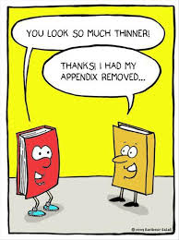

SCIENCE:
We will continue Newton’s 3 laws of motion. We will try to get to activities each day to reinforce these concepts, watch Bill Nye videos, and be completing outlines that go along with the text.

SOCIAL STUDIES:
We will continue to study the Revolutionary War, read about the Constitution in our Wonders text, and hopefully, analyze a poem about Paul Revere.

